Wave Blue Order Form
April - Child Abuse Prevention Month
Adams County, our community, our kids. Prevention is in our hands.
- Display the garden flag and sign at your home, workplace, or community organization.
- Purchase includes both garden flag and yard sign (with display stands)
- Pricing: 1 set for $25, 2 sets for $35, or 3 sets for $45
- Please return this form by March 17, 2023 to: 450 West Middle Street, Gettysburg, PA 17325
Fax: 717-337-9880 or by email JHendricks@kidsagaincac.org
- Payment options: Cash, credit card, check or online.
- Checks should be made out to Adams County Children’s Advocacy Center
- Pay online via www.kidsagaincac.org/donate --if choosing this option, please indicate as flag order
- Orders available for pick-up at ACCAC from 9:00am-4:00pm on Wednesday March 22, Friday March 24, & Wednesday March 29
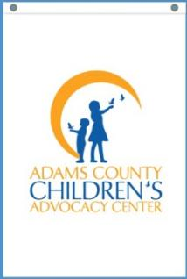
- If you have questions, please call us at 717-337-9888.
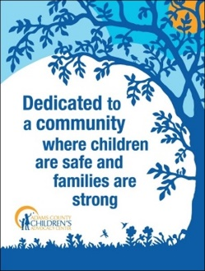

2’ x 3’ Yard Sign 12” x 18” Garden Flag

Name: | Click or tap here to enter text. |  | Organization/Company: |  | Click here to enter text.
Street Address: | Click or tap here to enter text. |  | City: |  | Click here to enter text.
State: | Click or tap here to enter text. |  | Zip Code: |  | Click here to enter text.
Email: | Click or tap here to enter text. |  | Phone: |  | Click here to enter text.
Item |  | Quantity |  | Price
Flag & Yard Sign Set |  | Click here to enter quantity. |  | Click here to enter price
Total |  |  |  | Click here to enter total price.

☐Cash ☐ Check ☐ Credit Card ☐ Discover ☐ Visa ☐ MasterCard

Card Number:  Click or tap here to enter text. | Name on Card:  Click or tap here to enter text. | Signature:  Click or tap here to enter text. | Expiration Date:  Click or tap here to enter text.  Security Code:  Click or tap here to enter text.

